Brent Jones Portfolio

**Table of Contents**

Section Page

**Code Fragments**…………………………………………………………………………………………………………………2

C#……………………………………………………………………………………………………………………………………3

CSS………………………………………………………………………………………………………………………………14

HTML……………………………………………………………………………………………………………………………17

Java……………………………………………………………………………………………………………………………21

SQL………………………………………………………………………………………………………………………………24

**Wireframes**…………………………………………………………………………………………………………………………35

**Technical Writing**………………………………………………………………………………………………………42

Case Studies……………………………………………………………………………………………………………43

Diagrams……………………………………………………………………………………………………………………77

Use Cases…………………………………………………………………………………………………………………83

# 

# Code Fragments

## In this section you will see code examples from projects done during classes at University of Louisville. Located at the top of each example is a comment explaining what the code shown will accomplish

***C#***

using System;

using System.Collections.Generic; using System.ComponentModel; using System.Data;

using System.Drawing; using System.Linq; using System.Text;

using System.Threading.Tasks; using System.Windows.Forms;

namespace Lab3

{ // Brent Jones, Lab 3, Due Feb 10, CIS 199-01, This Program when given the Dollar Value of your

//Dinner will Give you the amount of a 15, 18, and 20% Tip. public partial class Lab3Form : Form

{

public Lab3Form()

{

InitializeComponent();

}

private void CalculateTipButton_Click(object sender, EventArgs e)

{

const double CHEAPTIP = .15; // Provides a Constant value for what is considered a Cheap Tip

const double MODTIP = .18; // Provides a Constant value for what is considered a Moderate Tip

const double HIGHTIP = .20; // Provides a Constant value for what is considered a High Tip

double MealPricebefore; // Defines a Variable for Total Meal Price double MealpriceafterCHEAP; // Defines a Value for a Cheap Tipper double MealpriceafterMOD; // Defines a Value for a Moderate Tipper double MealpriceafterHIGH; // Defines a Value for a High Tipper

MealPricebefore = double.Parse(MealPriceTextBox.Text); // Translates the Text from Mealpricetextbox into a double number and defines it

MealpriceafterCHEAP = MealPricebefore * CHEAPTIP; // Multiplies to find the Price of a cheap tip

CheapTipOutputLabel.Text = MealpriceafterCHEAP.ToString(); // Translates the cheap tip into string text for a output label

Moderate Tip

MealpriceafterMOD = MealPricebefore * MODTIP; // Multiples to find the

ModTipOutputLabel.Text = MealpriceafterMOD.ToString(); // Translates the

Moderate tip into string text for a output label

high tip

MealpriceafterHIGH = MealPricebefore * HIGHTIP; // Multiplies to find the

HighTipOutputLabel.Text = MealpriceafterHIGH.ToString(); // Translates the

High tip into string text for a output label

}

}

}

using System;

using System.Collections.Generic; using System.Linq;

using System.Text;

using System.Threading.Tasks;

namespace Program_4//Brent Jones, Will return the value for shipping a specified package.

{

public class GroundPackage//declares class

{

public const int intval = 0; public const double doubval = 0; public const int zipMin = 00000; public const int zipMax = 99999;

public const double specsMin = 0;//declares constant variables with values.

public int _OriginZip; public int _DestinationZip; public double _Length; public double _Width; public double _Height;

public double _Weight;//declares instance variables with no values

public GroundPackage()

{

values

OriginZip = intval; DestinationZip = intval; Length = doubval;

Width = doubval; Height = doubval;

Weight = doubval; //parameterless constructor that assigns propertys initial

}

public int OriginZip//initializes an int variable

{

get

{

}

set

{

return _OriginZip; //returns value in variable

if((value >= zipMin) && (value <= zipMax))

_OriginZip = value;//postcondition:tests and sets value to variable

}

}

public int DestinationZip//initializes an int variable

{

get

{

}

Return _DestinationZip;//returns value in variable

variable

}

set

{

}

if ((value >= zipMin) && (value <= zipMax))

_DestinationZip = value;//postcondition:tests and sets value to

public double Length//initializes and declares a double variable

{

get

{

}

set

{

}

}

return _Length;//returns value in variable

if (value > specsMin)

_Length = value;//postcondition:tests and sets value to variable

public double Width//initializes and declares a double variable

{

get

{

}

set

{

}

}

return _Width;//returns value in variable

if (value > specsMin)

_Width = value;//Postcondition:tests and sets value to variable

public double Height//initializes and declares a double variable

{

get

{

}

set

{

}

}

return _Height;//returns value in variable

if (value > specsMin)

_Height = value;//Postcondition:tests and sets value to variable

public double Weight//initializes and declares a double variable

{

get

{

}

set

{

}

}

return _Weight;//returns value in variable

if (value > specsMin)

_Weight = value;//Postcondition:tests and sets value to variable

public int ZoneDistance// initializes and declares a variable

{ get

{

return zipMax - zipMin; // returns the difference in the values

}

}

public object CalcCost()//initializes and declares a method

{

return .20 * (Length + Width + Height) + .5 * (ZoneDistance + 1) * (Weight);//find and returns stated value.

}

public override string ToString()// declares the overriding method tostring()

{

return OriginZip.ToString("n/") + DestinationZip.ToString("n/") + Length.ToString("n/") + Width.ToString("n/") + Height.ToString("n/") +

Weight.ToString("n/");//sets the organization of the returned list values

}

}

}

using System;

using System.Collections.Generic; using System.ComponentModel; using System.Data;

using System.Drawing; using System.Linq; using System.Text;

using System.Threading.Tasks; using System.Windows.Forms;

namespace Project2 /* Brent Jones, Program 2, CIS 199-01, Due:3/10, This program when having

avaliable

{

* the appropriate data into it will give you back the earliest
* registration date for the student*/

public partial class Program2Form : Form

{

public Program2Form()

{

InitializeComponent();

}

private void CalculateButton_Click(object sender, EventArgs e)

{

times

string registration830 = "8:30"; string registration10 = "10:00"; string registration1130 = "11:30"; string registration2 = "2:00";

string registration4 = "4:00"; //Used to Make it easier to readily change

string freshmanApril8 = "April, 8"; string freshmanApril7 = "April, 7"; string sophomoreApril6 = "April, 6"; string sophomoreApril3 = "April, 3"; string juniorApril2 = "April, 2";

string seniorApril1 = "April, 1"; //Used to define the dates that assigned char lastNameLetter;

string lastNameString;

lastNameString = lastNameTextbox.Text.ToUpper();

lastNameLetter = lastNameString[0]; /* Defines the first character of the

last name entered

and makes all values entered uppercase while looking at only the first

character*/

if (FreshmanRadio.Checked)//displays the code that determines when freshman should sign up

{

if (lastNameLetter >= 'W')

{

MessageBox.Show(registration10 + " " + freshmanApril7);

}

else if (lastNameLetter >= 'T')

{

MessageBox.Show(registration830 + " " + freshmanApril7);

}

else if (lastNameLetter >= 'R'){

MessageBox.Show(registration4 + " " + freshmanApril8);

}

else if (lastNameLetter >= 'P')

{

MessageBox.Show(registration2 + " " + freshmanApril8);

}

else if (lastNameLetter >= 'M')

{

MessageBox.Show(registration1130 + " " + freshmanApril8);

}

else if(lastNameLetter >= 'J')

{

MessageBox.Show(registration10 + " " + freshmanApril8);

}

else if(lastNameLetter >= 'G')

{

MessageBox.Show(registration830 + " " + freshmanApril8);

}

else if(lastNameLetter >= 'E')

{

MessageBox.Show(registration4 + " " + freshmanApril7);

}

else if(lastNameLetter >= 'C')

{

MessageBox.Show(registration2 + " " + freshmanApril7);

}

else if(lastNameLetter >= 'A')

{

MessageBox.Show(registration1130 + " " + freshmanApril7);

}

}

if (SophomoreRadio.Checked)//displays the code that determines when sophomores should sign up

{

if (lastNameLetter >= 'W')

{

MessageBox.Show(registration10 + " " + sophomoreApril3);

}

else if (lastNameLetter >= 'T')

{

MessageBox.Show(registration830 + " " + sophomoreApril3);

}

else if (lastNameLetter >= 'R')

{

MessageBox.Show(registration4 + " " + sophomoreApril6);

}

else if (lastNameLetter >= 'P')

{

MessageBox.Show(registration2 + " " + sophomoreApril6);

}

else if (lastNameLetter >= 'M')

{

MessageBox.Show(registration1130 + " " + sophomoreApril6);

}

else if (lastNameLetter >= 'J')

{MessageBox.Show(registration10 + " " + sophomoreApril6);

}

else if (lastNameLetter >= 'G')

{

MessageBox.Show(registration830 + " " + sophomoreApril6);

}

else if (lastNameLetter >= 'E')

{

MessageBox.Show(registration4 + " " + sophomoreApril3);

}

else if (lastNameLetter >= 'C')

{

MessageBox.Show(registration2 + " " + sophomoreApril3);

}

else if (lastNameLetter >= 'A')

{

MessageBox.Show(registration1130 + " " + sophomoreApril3);

}

}

if (JuniorRadio.Checked)//displays the code that determines when juniors should sign up

{

if (lastNameLetter >= 'T')

{

MessageBox.Show(registration830 + " " + juniorApril2);

}

else if (lastNameLetter >= 'P')

{

MessageBox.Show(registration4 + " " + juniorApril2);

}

else if (lastNameLetter >= 'J')

{

MessageBox.Show(registration2 + " " + juniorApril2);

}

else if (lastNameLetter >= 'E')

{

MessageBox.Show(registration1130 + " " + juniorApril2);

}

else if (lastNameLetter >= 'A')

{

MessageBox.Show(registration10 + " " + juniorApril2);

}

}

if (SeniorRadio.Checked)//displays the code that determines when seniors should sign up

{

if (lastNameLetter >= 'T')

{

MessageBox.Show(registration830 + " " + seniorApril1);

}

else if (lastNameLetter >= 'P')

{

MessageBox.Show(registration4 + " " + seniorApril1);

}

else if (lastNameLetter >= 'J')

{

MessageBox.Show(registration2 + " " + seniorApril1);

}else if (lastNameLetter >= 'E')

{

MessageBox.Show(registration1130 + " " + seniorApril1);

}

else if (lastNameLetter >= 'A')

{

MessageBox.Show(registration10 + " " + seniorApril1);

}

}

}

}

}

using System;

using System.Collections.Generic; using System.Linq;

using System.Text;

using System.Threading.Tasks;

namespace Lab5 /* Brent Jones, Lab 5, Due 3/10, CIS 199-01, when ran this program will display

* asterisks in the order specified */

{

class Program

{

static void Main(string[] args)

{

const int maxRows = 10; // one constant that works throughout the program to state max rows

for (int rowsA = 1; rowsA <= maxRows; rowsA++)

{

for (int asterisk = 1; asterisk <= rowsA; asterisk++)

{

Console.Write("*");

}

Console.WriteLine(); //gives 10 iterations to display astericks in

ascending order

}

for (int rowsB = 1; rowsB <= maxRows; rowsB++)

{

for (int asterisk = 10; asterisk >= rowsB; asterisk--)

{

Console.Write("*");

}

Console.WriteLine(); //displays astericks in descending order

}

for (int rowsC = 1; rowsC <= maxRows; rowsC++)

{

for (int asterisk = 1; asterisk <= rowsC; asterisk++)

{

Console.Write(" ");

}

for (int space = 10; space >= rowsC; space--)

{

Console.Write("*");

}

Console.WriteLine(); // displays in console application ascending and descending iterations of spaces and astericks

}

for (int rowsD = 1; rowsD <= maxRows; rowsD++)

{

for (int asterisk = 10; asterisk >= rowsD; asterisk--)

{

Console.Write(" ");

}

for (int space = 1; space <= rowsD; space++)

{

Console.Write("*");

}

Console.WriteLine(); //// displays in console application ascending and descending iterations of spaces and astericks

}

}

}

}

# CSS

/* The CSS file corresponding to the online library shown in the wireframes section */

body {

padding-top: 50px; padding-bottom: 20px; background-color: orange; color: black;

}

/* Set padding to keep content from hitting the edges */

.body-content {

padding-left: 15px; padding-right: 15px;

}

/* Override the default bootstrap behavior where horizontal description lists will truncate terms that are too long to fit in the left column

*/

.dl-horizontal dt { white-space: normal;

}

/* Set width on the form input elements since they're 100% wide by default */ input,

select, textarea {

max-width: 280px;

}

.jumbotron

{

font-size:40px;

background-color: orange ; color: #000;

font-family: 'Oswald', sans-serif; border-style: double;

border-width: 6px; border-left-width: 10px; border-right-width: 10px; border-color: #000;

}

hr { border: 0;

color: black;

background-color: black; height: 1px;

width: 100%;

text-align: left;

}

table, tr, td {

border: 1px solid black;

}

@font-face {

font-family: 'Oswald', sans-serif;

src: URL('https://fonts.googleapis.com/css?family=Oswald');

}

h1{font-family: 'Oswald', sans-serif;}

.foo {

outline: 1px black;

}

container{

outline: 1px black;

}

# HTML

<!-- Code showing the Html code involved in making the Home Page of the online Library shown

in the Wireframes section -->

@model IEnumerable<CIS411_Final_Library.Models.BookListReview>

@{

ViewBag.Title = "Index";

}

<link href='https://fonts.googleapis.com/css?family=Oswald' rel='stylesheet' type='text/css'>

<div class="jumbotron">

<h1 align="center">CIS411 Book Library</h1>

<p align="center">A Place to RATE and REVIEW books</p>

<div class="container">

<div class="row">

<div class="col-md-12 col-md-offset-0" centerfy>

<div id="mycarousel" class="carousel slide" data-ride="carousel">

<ol class="carousel-indicators">

class="active"></li>

class="active"></li> class="active"></li>

<li data-target="#mycarousel" data-slide-to="0"

<li data-target="#mycarousel" data-slide-to="1"

<li data-target="#mycarousel" data-slide-to="2"

</ol>

<div class="carousel-inner">

<div class="item active">

<img src="/images/car_img5.png" width="1500" height="500" />

</div>

<div class="item">

<img src="/images/car_img8.jpg" width="1500" height="500" />

</div>

<div class="item">

<img src="/images/car_img4.jpg" width="1500" height="500" />

</div>

</div>

</div>

</div>

</div>

</div>

<p><center> <img src="/images/4.5_StarRating-1024x167.png" style="width:250px;height:45px;" /> </center></p>

</div>

<h2> <u>Featured 5 Star Books:</u> </h2>

<br />

<div class="container">

<div class="row">

<div class="col-md-4">

<center>

<img style="border:1px solid black;" src="~/images/car_img1.jpg" width="200" height="250" />

<p><u>The Great Gatsby</u></p>

<img src="~/images/five-star-review.png" width="150" height="30" />

</center>

</div>

<div class="col-md-4">

<center>

<img style="border:1px solid black;" src="~/images/car_img2.jpg" width="200" height="250" />

<p><u>A Tale of Two Cities</u></p>

<img src="~/images/five-star-review.png" width="150" height="30" />

</center>

</div>

<div class="col-md-4">

<center>

<img style="border:1px solid black;" src="~/images/car_img3.jpg" width="200" height="250" />

<p><u>A Farwell to Arms</u></p>

<img src="~/images/five-star-review.png" width="150" height="30" />

</center>

</div>

</div>

</div>

<br />

<br />

<br />

<br />

<div class="row">

<div class="col-md-4">

<h2><u>Group Members</u></h2>

<p>Alaa Hawsawi</p>

<p>Brent Jones</p>

<p>Eythan Decker</p>

<p>Khang Dinh</p>

</div>

<div class="col-md-4">

<h2><u>About</u></h2>

<p>

This is our final project for CIS411. It's a web application where authors and their readers can interact with each other. Authors can list their books and readers can comment, rate and review it.

</p>

</div>

<div class="col-md-4">

<h2><u>Contact Us</u></h2>

<p><a class="btn btn-default">Email &raquo;</a></p>

<p><a class="btn btn-primary" href="https://[www.facebook.com/](http://www.facebook.com/)">Facebook &raquo;</a></p>

<p><a class="btn btn-info" href="https://[www.twitter.com/](http://www.twitter.com/)">Twitter &raquo;</a></p>

<p><a class="btn btn-danger" href="https://plus.google.com/collections/featured">Google+ &raquo;</a></p>

</div>

</div>

# Java

**/* Code showing the creation of a simple rock paper scissors app for android devices built in android studio */**

**package** bsjone04.rockpaperscissorshw4_bsjones;

**import** android.support.v7.app.AppCompatActivity;

**import** android.os.Bundle; **import** android.view.View; **import** android.widget.Button;

**import** android.widget.ImageView;

**import** android.widget.Toast;

**import** java.util.Random;

**public class** MainActivity **extends** AppCompatActivity { Button rock, paper, scissors;

ImageView icon1, icon2;

String playerClick, cpuClick, result; Random r;

@Override

**protected void** onCreate(Bundle savedInstanceState) { **super**.onCreate(savedInstanceState); setContentView(R.layout.activity_main);

icon1 = (ImageView) findViewById(R.id.icon1);

icon2 = (ImageView) findViewById(R.id.icon2);

rock = (Button) findViewById(R.id.rock); paper = (Button) findViewById(R.id.paper);

scissors = (Button) findViewById(R.id.scissors); r = **new** Random();

rock.setOnClickListener(**new** View.OnClickListener() {

@Override

**public void** onClick(View v) { playerClick = **"rock"**;

icon2.setImageResource(R.drawable.rock); calculate();

}

});

paper.setOnClickListener(**new** View.OnClickListener() {

@Override

**public void** onClick(View v) { playerClick = **"paper"**;

icon2.setImageResource(R.drawable.paper); calculate();

}

});

scissors.setOnClickListener(**new** View.OnClickListener() {

@Override

**public void** onClick(View v) {

playerClick = **"scissors"**; icon2.setImageResource(R.drawable.scissors); calculate();

}

});

}

**public void** calculate() { **int** cpu = **r**.nextInt(3); **if**(cpu == 0) {

**cpuClick** = **"rock"**; **icon1**.setImageResource(R.drawable.rock);

}

**else if**(cpu == 1){ cpuClick = **"paper"**;

icon1.setImageResource(R.drawable.paper);

}

**else if** (cpu == 2) { cpuClick = **"scissors"**;

icon1.setImageResource(R.drawable.scissors);

}

**if**(playerClick.equals(**"rock"**) && cpuClick.equals(**"paper"**)){ result = **"you lose"**;

}

**else if**(playerClick.equals(**"rock"**) && cpuClick.equals(**"scissors"**)){ result = **"you win"**;

}

**else if**(playerClick.equals(**"paper"**) && cpuClick.equals(**"rock"**)){ result = **"you win"**;

}

**else if**(playerClick.equals(**"paper"**) && cpuClick.equals(**"scissors"**)){ result = **"you lose"**;

}

**else if**(playerClick.equals(**"scissors"**) && cpuClick.equals(**"paper"**)){ result = **"you win"**;

}

**else if**(playerClick.equals(**"scissors"**) && cpuClick.equals(**"rock"**)){ result = **"you lose"**;

}

**else if**(playerClick.equals(**"scissors"**) && cpuClick.equals(**"scissors"**)){ result = **"you tie"**;

}

**else if**(playerClick.equals(**"rock"**) && cpuClick.equals(**"rock"**)){ result = **"you tie"**;

}

**else if**(playerClick.equals(**"paper"**) && cpuClick.equals(**"paper"**)){ result = **"you tie"**;

}

Toast.makeText(MainActivity.**this**,result,Toast.LENGTH_SHORT).show();

}

}

}

# SQL

###### --Code showing Simple SQL queries into a movie database

--BRENT JONES

--A8

--3/8/2016

--PROF.GUAN

--72

SELECT MOVIE_TITLE, MOVIE_YEAR, MOVIE_GENRE FROM MOVIE

--73

SELECT MOVIE_YEAR, MOVIE_TITLE, MOVIE_COST FROM MOVIE

ORDER BY MOVIE_YEAR DESC;

--74

SELECT MOVIE_TITLE, MOVIE_YEAR, MOVIE_GENRE FROM MOVIE

ORDER BY MOVIE_GENRE, MOVIE_YEAR DESC;

--75

SELECT MOVIE_NUM, MOVIE_TITLE, PRICE_CODE FROM MOVIE

WHERE MOVIE_TITLE LIKE 'R%';

--76

SELECT MOVIE_TITLE, MOVIE_YEAR, MOVIE_COST FROM MOVIE

WHERE UPPER(MOVIE_TITLE) LIKE '%HOPE%' ORDER BY MOVIE_TITLE;

--77

SELECT MOVIE_TITLE, MOVIE_YEAR, MOVIE_GENRE FROM MOVIE

WHERE MOVIE_GENRE = 'ACTION';

--78

SELECT MOVIE_NUM, MOVIE_TITLE, MOVIE_COST FROM MOVIE

WHERE MOVIE_COST > 40;

--79

SELECT MOVIE_NUM, MOVIE_TITLE, MOVIE_COST, MOVIE_GENRE FROM MOVIE

WHERE (MOVIE_GENRE = 'ACTION'OR MOVIE_GENRE ='COMEDY') AND MOVIE_COST <50 ORDER BY MOVIE_GENRE;

--80

SELECT MOVIE_NUM, (MOVIE_TITLE + MOVIE_YEAR + MOVIE_GENRE) AS "Movie

Description" FROM MOVIE;

--81

SELECT MOVIE_GENRE, COUNT(*) AS "Number of Movies" FROM MOVIE

GROUP BY MOVIE_GENRE;

--82

SELECT AVG(MOVIE_COST) AS "Average Movie Cost" FROM MOVIE;

--83

SELECT MOVIE_GENRE, AVG(MOVIE_COST) AS "Average Cost" FROM MOVIE

GROUP BY MOVIE_GENRE;

--84

SELECT MOVIE_TITLE, MOVIE_GENRE, PRICE_DESCRIPTION, PRICE_RENTFEE FROM MOVIE, PRICE

WHERE MOVIE.PRICE_CODE = PRICE.PRICE_CODE

--85

SELECT MOVIE.MOVIE_GENRE, AVG(PRICE_RENTFEE) AS "Average Rental Fee" FROM MOVIE, PRICE

WHERE MOVIE.PRICE_CODE = PRICE.PRICE_CODE;

--86

SELECT MOVIE_TITLE, MOVIE_YEAR, MOVIE_COST / PRICE_RENTFEE AS "BREAKEVEN RENTALS"

FROM MOVIE, PRICE

WHERE MOVIE.PRICE_CODE = PRICE.PRICE_CODE;

--87

SELECT MOVIE_TITLE, MOVIE_YEAR FROM MOVIE

WHERE PRICE_CODE IS NOT NULL;

--88

SELECT MOVIE_TITLE, MOVIE_YEAR, MOVIE_COST FROM MOVIE

WHERE MOVIE_COST >= 44.99 AND MOVIE_COST <= 49.99;

--89

SELECT MOVIE_TITLE, MOVIE_YEAR, PRICE_DESCRIPTION, PRICE_RENTFEE, MOVIE_GENRE FROM MOVIE,PRICE

WHERE MOVIE.PRICE_CODE = PRICE.PRICE_CODE AND MOVIE_GENRE IN ('FAMILY', 'COMEDY','DRAMA');

--90

SELECT MOVIE.MOVIE_NUM, MOVIE_TITLE, MOVIE_YEAR

FROM MOVIE LEFT JOIN VIDEO ON MOVIE.MOVIE_NUM = VIDEO.MOVIE_NUM WHERE VIDEO.MOVIE_NUM IS NULL;

--91

SELECT DISTINCT MEMBERSHIP.MEM_NUM, MEM_FNAME, MEM_LNAME,MEM_BALANCE FROM MEMBERSHIP, RENTAL

WHERE MEMBERSHIP.MEM_NUM = RENTAL.MEM_NUM;

--92

SELECT MIN(MEM_BALANCE) AS "Minimum Balance", MAX(MEM_BALANCE) AS "Maximum

Balance",AVG(MEM_BALANCE) AS "Average Balance" FROM MEMBERSHIP

WHERE MEM_NUM IN (SELECT MEM_NUM FROM RENTAL);

--93

SELECT (MEM_FNAME + MEM_LNAME) AS "Membership Name", (MEM_STREET + MEM_CITY + ', ' +

MEM_STATE + MEM_ZIP) AS "Membership Address" FROM MEMBERSHIP;

--94

SELECT RENTAL.RENT_NUM, RENT_DATE, VIDEO.VID_NUM, MOVIE_TITLE,DETAIL_DUEDATE, DETAIL_RETURNDATE

FROM RENTAL, DETAILRENTAL, VIDEO, MOVIE WHERE RENTAL.RENT_NUM = DETAILRENTAL.RENT_NUM AND DETAILRENTAL.VID_NUM = VIDEO.VID_NUM

AND VIDEO.MOVIE_NUM = MOVIE.MOVIE_NUM ORDER BY RENTAL.RENT_NUM, MOVIE_TITLE;

--96

SELECT RENTAL.RENT_NUM, RENT_DATE, MOVIE_TITLE, DETAIL_FEE FROM RENTAL, DETAILRENTAL, VIDEO, MOVIE

WHERE RENTAL.RENT_NUM = DETAILRENTAL.RENT_NUM AND DETAILRENTAL.VID_NUM = VIDEO.VID_NUM

AND VIDEO.MOVIE_NUM = MOVIE.MOVIE_NUM AND DETAIL_RETURNDATE <= DETAIL_DUEDATE;

--97

SELECT MEMBERSHIP.MEM_NUM, MEM_LNAME, MEM_FNAME, SUM(DETAILRENTAL.DETAIL_FEE) AS

"Rental Fee Revenue"FROM MEMBERSHIP, RENTAL, DETAILRENTAL

WHERE MEMBERSHIP.MEM_NUM = RENTAL.MEM_NUM AND RENTAL.RENT_NUM = DETAILRENTAL.RENT_NUM

GROUP BY MEMBERSHIP.MEM_NUM, MEM_LNAME, MEM_FNAME;

/* Code showing the creation and the alteration of a Table in SQL server 2012 */

/* Brent Jones CIS-310

A9-A

3/22/16 */

Create Table DETAILRENTALA (

Rent_Num int, Vid_Num int,

Detail_fee decimal(5,2), Detail_DueDate datetime, Detail_ReturnDate datetime, Detail_DailyLateFee decimal(5,2));

Create Table RentalA (

Rent_Num int, Rent_Date datetime, Mem_Num int)

Create Table VideoA (

Vid_Num int, Vid_InDate datetime, Movie_Num int)

Create Table MembershipA (

Mem_Num int,

Mem_FName Nvarchar(50), Mem_LName Nvarchar(50), Mem_Street Nvarchar(255), Mem_City Nvarchar(255), Mem_State Nvarchar(2), Mem_Zip Nvarchar(5), Mem_Balance decimal(5,2))

Create Table MovieA (

Movie_Num int, Movie_Title Nvarchar(255), Movie_Year smallint, Movie_Cost decimal(5,2), Movie_Genre Nvarchar(12), Price_Code smallint)

Create Table PriceA (

Price_Code smallint, Price_Description Nvarchar(50), Price_RentFee decimal, Price_DailyLateFee decimal,

)

Alter table RENTALA

--alter column Rent_Num int not null add Primary key (Rent_Num);

Alter table VideoA

--alter column Vid_Num int not null add primary key (Vid_Num);

Alter table DETAILRENTALA add foreign key (Rent_Num) References RentalA;

Alter table DETAILRENTALA add foreign key (Vid_Num) References VideoA;

Alter table MembershipA

--alter column Mem_Num int not null add primary key (Mem_Num);

Alter table PriceA

--alter column Price_Code smallint not null add primary key (Price_Code);

Alter table MovieA

--alter column Movie_Num int not null add primary key (Movie_Num);

Alter table RentalA

add foreign key (Mem_Num) References MembershipA;

Alter table VideoA

add foreign key (Movie_Num) References MovieA;

Alter table MovieA

add foreign key (Price_Code) References PriceA(Price_Code);

/* Code showing the creation and manipulation of a table NONGAME in Sql Server 2012 */

--Brent Jones

--CIS-310

--A9-B

--3/22/2016

--#1

Create table NONGAME (Item_Num char(4) not null, Description char(30), ON_HAND decimal(4,0), Category Char(3),

Price decimal(6,2))

--#2

Insert into NONGAME Select ITEM_NUM, DESCRIPTION, ON_HAND, CATEGORY, PRICE

from ITEM

where Category <> 'GME';

--#3

Update NONGAME

set Description = 'Classic Train Set' Where Item_Num = 'DL51'

--#4

UPDATE NONGAME

SET Price = Price * 1.02 WHERE Category = 'TOY';

--#5

Insert into NONGAME

values ('TL92', 'Dump Truck', '10', 'TOY', '59.95');

--#6

Delete

From NONGAME

Where category = 'PZL';

--#7

Update NONGAME

set category = NULL where ITEM_NUM = 'FD11';

--#8

Alter table NONGAME add ON_HAND_VALUE decimal(7,2); Update NONGAME

Set ON_HAND_VALUE = ON_HAND * Price;

--#9

Alter table NONGAME

Modify Description Char(40);

--#10

Drop Table NONGAME;

/* Queries from a Animal database that show examples of joins as well as order and group bys in Sql server 2012 */

--Brent Jones

--CIS 310-01

--A11

--4/10/2016

SELECT * FROM PET..ANIMAL

--1

Select m.ItemID, m.ListPrice From Pet..Merchandise m

Where m.ListPrice > (Select AVG(a.ListPrice) From Pet..Merchandise a)

--2

SELECT OrderItem.ItemID, SaleItem.ItemID, Merchandise.ItemID, Merchandise.Description, AVG(OrderItem.Cost)

AS AvgOfCost,

AVG(SaleItem.SalePrice) AS AvgOfSalePrice

FROM PET..OrderItem INNER JOIN PET..Merchandise ON OrderItem.ItemID = Merchandise.ItemID INNER JOIN

PET..SaleItem ON SaleItem.ItemID = Merchandise.ItemID

Group By OrderItem.ItemID, SaleItem.ItemID, Merchandise.ItemID,Merchandise.Description Having AVG(SaleItem.SalePrice) > 1.5*AVG(OrderItem.Cost)

--3

Select Employee.EmployeeID, Sale.SaleID, Merchandise.ItemID, SaleItem.SalePrice/(SaleItem.SalePrice)

From Pet..Employee Inner Join Pet..Sale ON Employee.EmployeeID = Sale.EmployeeID Inner Join Pet..SaleItem ON

Sale.SaleID = SaleItem.SaleID Inner

Join Pet..Merchandise ON Merchandise.ITEMID = SaleItem.ItemID

Group by Employee.EmployeeID, Sale.SaleID, Merchandise.ItemID, SaleItem.SalePrice

--4

Select AVG(MerchandiseOrder.ShippingCost)/(OrderItem.Quantity*OrderItem.Cost), MerchandiseOrder.PONumber,

OrderItem.PONumber

From Pet..MerchandiseOrder Inner Join Pet..OrderItem ON MerchandiseOrder.PONumber = OrderItem.PONumber

Group by MerchandiseOrder.PONumber, OrderItem.PONumber,MAX(AVG(MerchandiseOrder.ShippingCost)/(OrderItem.Quantity*OrderItem.C ost)),

AVG(MerchandiseOrder.ShippingCost)/(OrderItem.Quantity*OrderItem.Cost)

Having AVG(MerchandiseOrder.ShippingCost)/(OrderItem.Quantity*OrderItem.Cost) = MAX(AVG(MerchandiseOrder.ShippingCost)/(OrderItem.Quantity*OrderItem.Cost))

--5

SELECT Customer.CustomerID, Customer.FirstName, Customer.LastName, Sum(ListPrice*quantity) AS Highest

FROM Pet..Customer INNER JOIN Pet..Sale ON Customer.CustomerID = Sale.CustomerID INNER JOIN

Pet..Merchandise INNER JOIN Pet..SaleItem ON Merchandise.ItemID = SaleItem.ItemID ON Sale.SaleID =

SaleItem.SaleID

GROUP BY Customer.CustomerID, Customer.FirstName, Customer.LastName

ORDER BY Sum(ListPrice*quantity) DESC;

--6

Select Customer.CustomerID, Sum(OrderItem.Cost) AS Total

From Pet..MerchandiseOrder Inner Join Pet..OrderItem inner Join Pet..Merchandise

Inner Join Pet..SaleItem Inner Join Pet..Sale inner Join Pet..Customer ON Sale.CustomerID

= Customer.CustomerID

ON SaleITEM.SaleID = Sale.SaleId ON Merchandise.ITemID = SaleITem.ItemID ON OrderITem.ItemID =

Merchandise.ItemId

ON MerchandiseOrder.PONumber = OrderItem.POnumber Where (Pet..MerchandiseOrder.OrderDate Like 'May%')

And Customer.CustomerID IN (Select Customer.CustomerID

From Pet..MerchandiseOrder Inner Join Pet..OrderItem inner Join Pet..Merchandise

Inner Join Pet..SaleItem Inner Join Pet..Sale inner Join Pet..Customer ON Sale.CustomerID

= Customer.CustomerID

ON SaleITEM.SaleID = Sale.SaleId ON Merchandise.ITemID = SaleITem.ItemID ON OrderITem.ItemID =

Merchandise.ItemId

ON MerchandiseOrder.PONumber = OrderItem.POnumber Where (Pet..MerchandiseOrder.OrderDate LIKE 'Oct%') Group by Customer.CustomerID

Having Sum(Pet..OrderItem.Cost) > 50) Group by Customer.CustomerID

Having Sum(Pet..OrderItem.Cost) > 100;

--7

SELECT Month(SaleDate) AS [Month], Count(Sale.SaleID) AS CountofSales, Count(Sale.SaleID)

*SalePrice As Total

FROM Pet..Sale inner join Pet..SaleItem ON Sale.SaleId = Saleitem.Saleid inner Join pet..Merchandise ON

Saleitem.ItemId = Merchandise.ItemID

WHERE Saledate > '2004-01-1' AND SaleDate < '2004-07-1' ANd description = 'Dog Food-Can- Premium'

GROUP BY Month(SaleDate), SalePrice Order by Total Desc;

--8

SELECT Month(SaleDate) AS [Month], Count(Sale.SaleID) AS CountofSales, Merchandise.ListPrice

FROM Pet..Sale inner join Pet..SaleItem ON Sale.SaleId = Saleitem.Saleid inner Join pet..Merchandise ON

Saleitem.ItemId = Merchandise.ItemID

WHERE SaleDate > '2004-07-01' And Saledate < '2004-07-30' ANd ListPrice > '50' GROUP BY Month(SaleDate), ListPrice

Order by CountofSales

--9

SELECT S.NAME, 'ANIMAL' AS [Type of Sale]

FROM Pet..SUPPLIER S INNER JOIN pet..ANImALORDER O ON S.SUPPLIERID = O.SUPPLIERID WHERE MONTH(O.ORDERdATE) = 6

UNION

SELECT S.NAME, 'MERCHANDISE' AS [Type of Sale]

FROM peT..SUPPlIER S INNER JOIN PET..MERCHANDISEORDER M ON S.SUPPLIERID = M.SUPPLIERID WHERE MONTH(M.ORDERDATE) = 6

/* Code showing the creation of a trigger in Sql Server 2012 that acts upon an Insert or a Delete query into a stated database */

-- ================================================

-- Template generated from Template Explorer using:

-- Create Trigger (New Menu).SQL

--

-- Use the Specify Values for Template Parameters

-- command (Ctrl-Shift-M) to fill in the parameter

-- values below.

--

-- See additional Create Trigger templates for more

-- examples of different Trigger statements.

--

-- This block of comments will not be included in

-- the definition of the function.

-- ================================================ SET ANSI_NULLS ON

GO

SET QUOTED_IDENTIFIER ON GO

-- =============================================

-- Author: <Jones, Brent>

-- Create date: <3/29/2016>

-- Description:<A10 Trigger (Update_Balance)>

-- ============================================= PART-1/PART-2

ALTER TRIGGER Update_Balance ON ORDER_LINE

AFTER INSERT,DELETE,UPDATE AS

BEGIN

-- SET NOCOUNT ON added to prevent extra result sets from

-- interfering with SELECT statements. SET NOCOUNT ON;

DECLARE @CUSTOMER_NUM Decimal(8,2)

DECLARE @trgBalance Decimal(8,2)

-- Insert statements for INSERT trigger here IF(EXISTS (SELECT * FROM INSERTED))

BEGIN

DECLARE INSERTED_CURSOR CURSOR FOR

SELECT ORDER_NUM, SUM(NUM_ORDERED * QUOTED_PRICE) AS trgBalance FROM INSERTED

GROUP BY ORDER_NUM OPEN INSERTED_CURSOR

FETCH NEXT FROM INSERTED_CURSOR

INTO @CUSTOMER_NUM, @trgBalance

WHILE(@@FETCH_STATUS = 0) BEGIN

UPDATECUSTOMER

SET BALANCE = @trgBalance

WHERE CUSTOMER_NUM = @CUSTOMER_NUM FETCH NEXT FROM INSERTED_CURSOR

INTO @CUSTOMER_NUM, @trgBalance END

CLOSE INSERTED_CURSOR

DEALLOCATE INSERTED_CURSOR END

-- Insert statements for DELETE trigger here IF(EXISTS (SELECT * FROM DELETED))

BEGIN

DECLARE DELETED_CURSOR CURSOR FOR

SELECT ORDER_NUM, SUM(NUM_ORDERED * QUOTED_PRICE) AS trgBalance FROM DELETED

GROUP BY ORDER_NUM

OPEN DELETED_CURSOR

FETCH NEXT FROM DELETED_CURSOR

INTO @CUSTOMER_NUM, @trgBalance

WHILE(@@FETCH_STATUS = 0) BEGIN

UPDATECUSTOMER

SET BALANCE = @trgBalance

WHERE CUSTOMER_NUM = @CUSTOMER_NUM FETCH NEXT FROM INSERTED_CURSOR

INTO @CUSTOMER_NUM, @trgBalance END

CLOSE DELETED_CURSOR DEALLOCATE DELETED_CURSOR END

END GO

--TESING OF TRIGGER BELOW PART-3

SELECT *

FROM CUSTOMER

SELECT *

FROM ORDER_LINE ORDER BY ORDER_NUM

INSERT INTO ORDER_LINE

VALUES (51608, 'CD33', 10, 86.99)

DELETE FROM ORDER_LINE

WHERE NUM_ORDERED = 10 AND QUOTED_PRICE = 10

UPDATE ORDER_LINE SET NUM_ORDERED = 3

WHERE ORDER_NUM = 51608 AND ITEM_NUM = 'CD33'

# Wireframes

## In this section you will find wireframes from completed projects done during my time at the University of Louisville. Some of these wireframes correspond to diagrams and code fragments in their respective sections

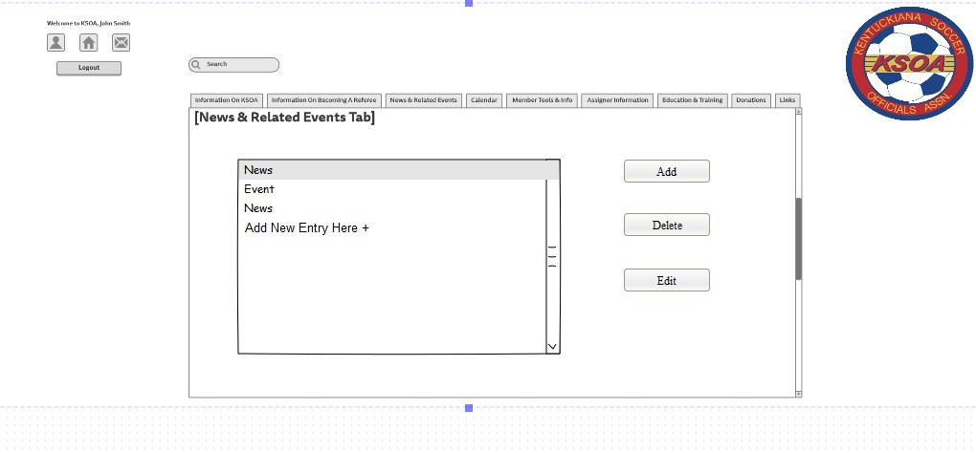

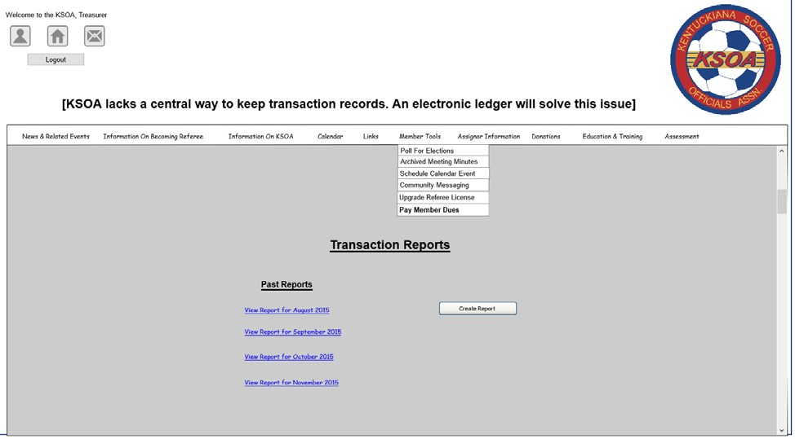

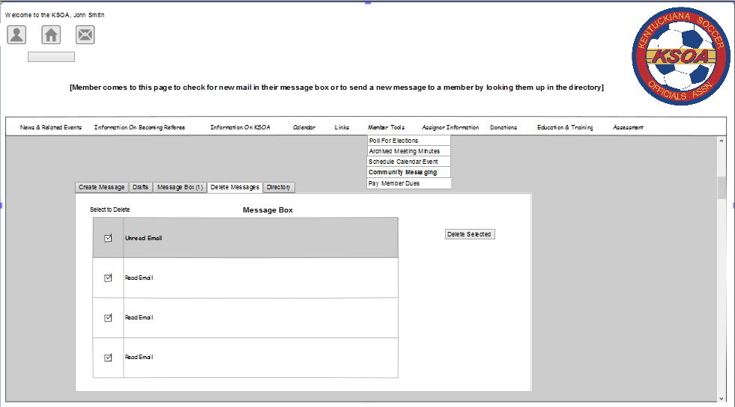

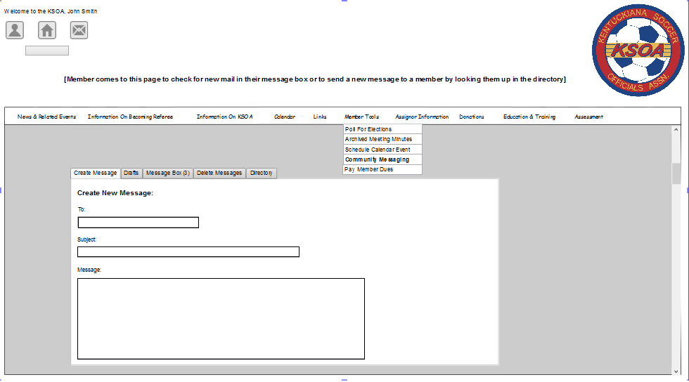

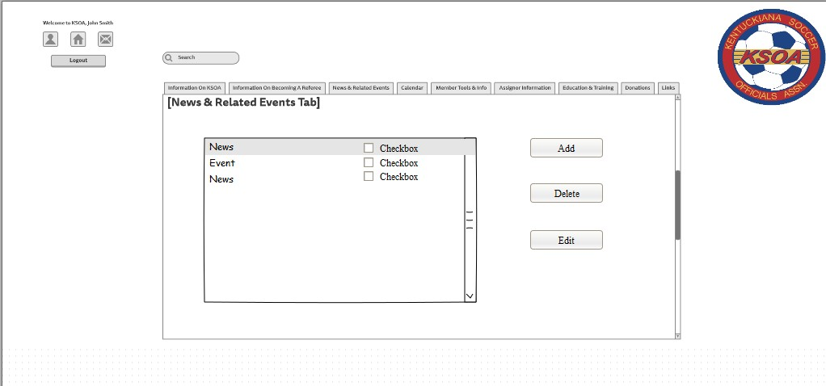

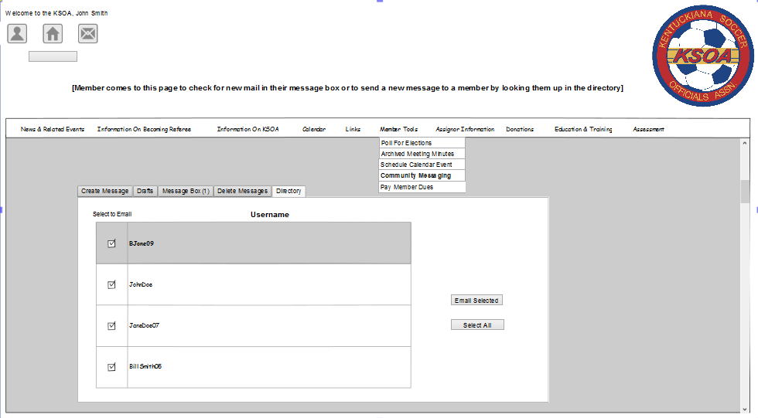

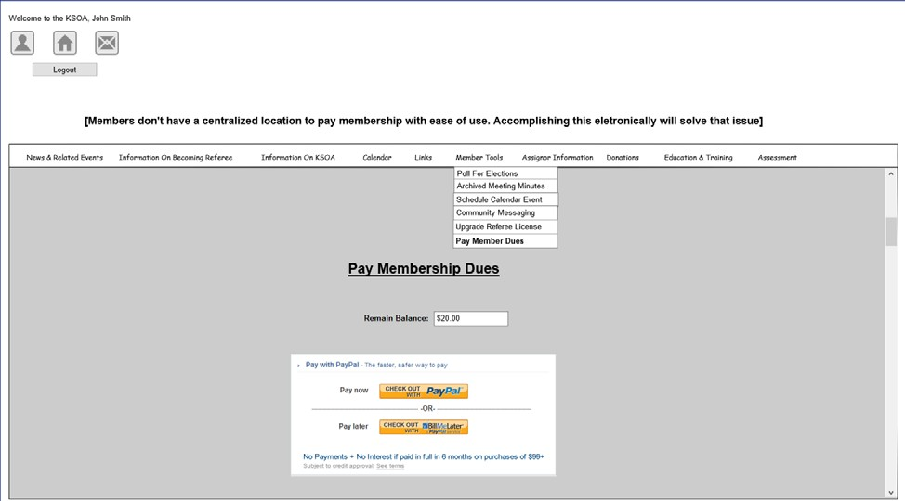

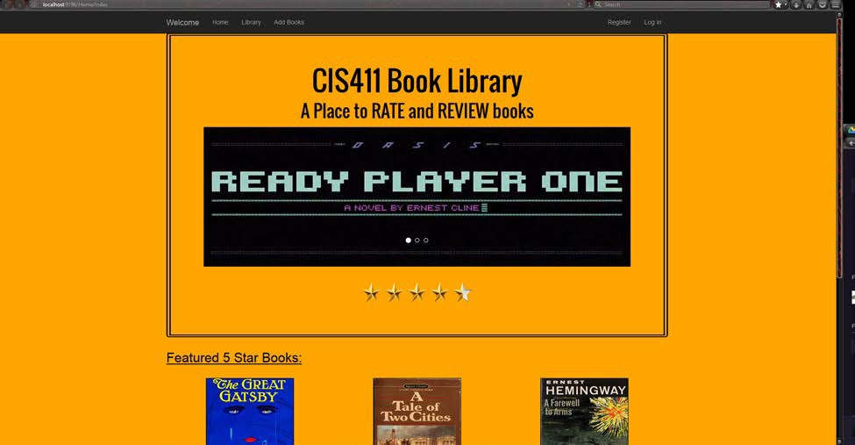

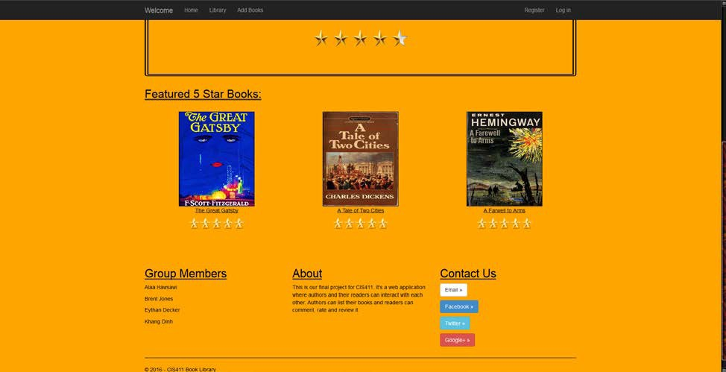

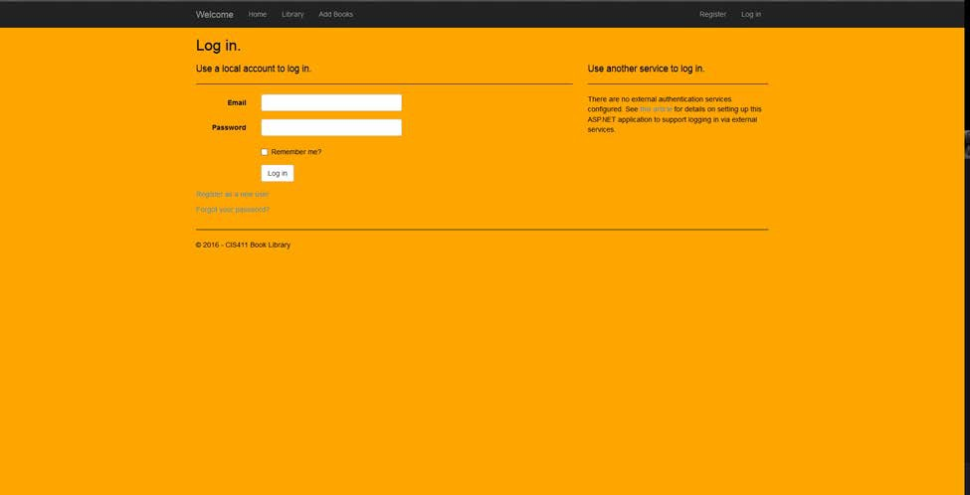

**Technical Writing**

In this section are examples of Relational and Class Diagrams as well as Use Cases for corresponding wireframes in the Wireframes section and from the SQL section as well as Case Studies I have written on various companies.

**Case Studies**

Case 02 Appex

Brent Jones 9/14/2016

#### Appex and the EDS Acquisition

Appex; formerly Appex Lunayach Systems Corporation, is a business that was founded in 1986 from a merger involving Appex inc. and Lunayach Communications Consultants. The CEO of Appex is Shikhar Ghosh. Its products and services are divided up into intercarrier services (ICS) and cellular management information systems (IS). For years Appex has been “Dancing to the beat of their own drum” in terms of organizational structure and formalities within the company and what once set them apart in a good way is now starting to look like its setting them apart in a bad way.

Appex has been acquired by a large information systems management company called Electronic Data Systems or EDS, which is a $6 billion dollar company owned by General Motors. Appex faces a problem with their organizational structure, they have been growing at such a fast rate (50% every 6 months) in terms of employees within the company that they have had to change their organizational structure at least twice a year. Appex has been picked up by EDS and they need to find a way to adjust Appex’s strategic direction in a way that it will align with EDS’s goals. EDS wants Appex to comply with their requirements in areas such as financial planning, resource allocation, and administrative procedures. Appex must begin to make structural adjustments to comply with being part of a larger bureaucratic organization.

#### Porters 5 forces Analysis

##### Competitive Rivalry

Appex is a company in the cellular communications market, in the late 1980s early 1990s this market had not been around long. This had a lot of pros and cons, one pro was simply that the market was booming in a big way for this technology, a con to this would be that there would be a lot of people wanting entry into this market. Appex is a dynamic company and in that way I believe they set themselves apart; they did reasonably well to adapt to ever changing work environments. Appex does have to worry about competition in this field though, with companies like GTE, Cincinnati Bell, and McDonnell Douglas putting out RFPs to establish joint entities along with possible overseas threats they need keep a watchful eye out for upcoming technologies and always be innovative in the cellular management systems market.

##### New Entrants

The cellular management systems market has entry margins relatively low compared to a lot of markets there could be a lot of new companies popping up looking to get their piece of the pie in the cellular management systems market. The thing about this field is that you don’t have to have a ton of resources to get started and all a startup company would need is that one big client to kick start your growth.

Big management systems companies are always looking to expand to new fields if the promise for increased revenues is there, knowing this Appex being picked up by such a big company like General Motors is a very good thing. GM will give Appex the resources it needs to really thrive against upcoming threats and keep them weak without destroying them, and to hold their own against other big business conglomerates in their market.

##### Supplier Power

Appex in terms of supplier power (as in the power that Appex holds over the cellular companies it provides services too) would have a moderate advantage as long as it stays innovative and does things other companies aren’t, it would be better if they had not been suffering from quality control problems and if they hadn’t just recently been picked up by another company. I believe this will make new prospective clients weary to hire them until they see how they do with the change.

##### Buyer Power

In terms of buyer power (the power that a cellular service provider has over Appex) would be marginally high right now. With many alternatives coming into the field they have a lot of options to choose from. If the buyer has a high volume job however Appexs newly gained resources it acquired by the EDS takeover make it a good choice. The buyer is likely to be able to get Appexs services at a satisfactory rate right now though because I believe they would want to continue to prove themselves to GM.

##### Substitutes

Appex now more than ever needs to be weary for substitutes in the market, with this market expanding and booming as much as it is coupled with its moderate entry walls there is going to be many alternatives to switch to if the quality of their service falls. Appex has a reputation for being an innovative company with lots of future growth. This along with a large company like GM at its back makes Appex stand out, but a smaller company looking to prove itself may be able to offer a better deal to a smaller cellular service provider then Appex could until it gets its organizational structure ironed out.

#### Stakeholders

When looking at all of the stakeholders that would be effected by the successful implementation of a new organizational structure you have to consider both Appex and its new owner EDS. The first stakeholder in this case is the Board members and stakeholders within EDS and Appex. These people would be the first to know if a change in their existing structure were to be implemented and if the change was a success or a failure. If it were a success of course they would increase revenues and if it was a failure they would at the least decrease revenues.

A second stakeholder in this case would be the employees that would be effected by the organizational structure, many people could potentially get promoted or demoted some people could even get fired or laid off. These people could be working in new departments with new co-workers in the blink of an eye if the company thinks it will help future revenues and organizational fluidity.

A third stakeholder in this case would be the customers that currently use the management systems that Appex provides. If a new organizational structure were designed and implemented this could affect the quality and efficiency of Appex for better or worse, and how innovative they are in the future.

#### Alternatives

1. The first alternative in this case is to decide to change their organizational structure to one of a different adaptation of their already implemented divisional structure in which they implement new team members from within EDS to each division and with the resources provided by GM finally start focusing on output and innovation again. In this alternative Appex would have to stop employing so many additional people and spending so much money on training and focus on dividing up their organization until they find the pairing that works.
2. The second alternative in this case is to go back to a more functional way of organization. This would involve Appex (while adjusting to the guidelines that EDS has for them) to change back to a clear cut division in structure of their company. It would divide Appex back up into divisions such as R&D, sales, and marketing. This would require a lot of information exchange between the divisions, but implementing this it would keep the authority issues in check.
3. The third option in this case would be to do nothing and not move toward a more static organizational structure with the backing of GM. In this option Appex would keep

changing their organizational structure very frequently to meet their needs and may continue to have quality and authority issues within their organization.

#### Analysis

If Appex were to choose to go tweak their existing organizational structure to fit the requirements laid out by EDS and GM and decide to go with a divisional structure this would require Appex to address some issues that they have been having. Appex would first need to decide what a proper number of groups within their organization was, and allocate all the essential members to it. They would need to make sure these groups worked together well and did not have to bicker over resources to each one. This alternative would focus on the output of each group and what they were accomplishing, so if there was a weak link it would need to be found. This alternative would be a means to an end and would require them to stop taking on so many new employees and spending lots of resources training people in this new market. This alternative would be working toward a more static longer lasting organization solution.

If Appex were to choose alternative two and decide to go with a functional organizational structure then they would have to break up all of their current employees into their respective fields of profession to work toward a more static business solution. This would help improve the companies’ quality, but may not spark back up the innovation that Appex is known for due to potential lack of communication between divisions. Since this market is a relatively new one this may not be a great idea considering functional organizations typically

struggle with differentiated environments and Appex provides a few different types of products and services.

If Appex chose to do nothing and keep the ever changing organizational structure it has it could potentially allow for some areas to suffer such as innovation and quality considering the employees at Appex and EDS would never really adjust to their workplace and would constantly have things to worry about besides innovation. This alternative would allow them to keep expanding and changing structures until they found something that sticks as well.

#### Comparison

When thinking about what organizational structure Appex should choose you have to consider all the things involved. You have to consider the organization that just bought you, the people involved by the decision you make, and what exactly is the best choice to help my business grow. I believe that the best choice for Appex is to do nothing and stick to what has been working. Appex will naturally have to comply with the demands of EDS, but I believe this is obtainable through this approach. “There is no one best way of organizing. The appropriate form depends on the kind of task or environment with which one is dealing” (Morgan) I believe this quote sums up the reasoning behind my answer. This company is in a market that is relatively new and it is going to encounter things that have never been encountered before. I believe that the ability to adapt and continue to grow until they find the ideal size they have been looking for is a better idea then designing one organizational structure and trying to go by it. A functional or divisional organizational structure may work for your company at the moment, but that doesn’t mean it will a week from today or a month from today. Appex will

need to adjust the areas where they have been slipping though such as quality control, authority, and innovation. They keep changing their structure the way they have been until they find their Apex. This system may come with a lot of uncertainties, but they have had nothing but continued growth under Ghosh. Ghosh was involved in nearly every operation while using a functional structure, and in a divisional structure he has had more free time to tend to his responsibilities. I think its best that Appex stays adaptive instead of deciding on one structure or another. One organizational structure may be better at the moment but with the growth they are experiencing they will always have different needs.

## Case 03 Symantec

Brent Jones 9/28/16

#### Symantec: Poor Management or Communication?

Symantec; a software company that designed, delivered, and supported multiple software suites for business needs was founded in March 1982 by Gary Hendrix. It then combined with another software company in 1984 called C&E software and became known as Symantec Corperation. Hendrix became the vice president and Gordon Eubanks (Founder of C&E Software) became the president/CEO.

Symantec has grown from 30 employees to 300 employees over the first 8 years of its life and as it is growing as a company it is retaining some of its small company policies such as no outlined communication flow or system, and a lack of quality management staff. Symantec is suffering from a lack of communication, they are spending way too much time and resources trying to re-invent the wheel over and over because of lack of communication. Hendrix and Eubanks have both expressed their concerns of this issue and are faced with multiple possible actions to take in an effort to resolve this problem. They have had an act-now, fix-later type of attitude as a company thus far and need to start planning for the future now that they have the money and resources to do so.

#### Porters 5 Forces Analysis

**Competitive Rivalry**

Symantec is a software design, deliver, and support company and thus it competes with companies that do either of those three things for businesses. Symantec is doing very well at this point in its life as it is having more orders then it’s currently capable of taking and their

company is growing at such a rate that they have the opportunity to change the whole way their company functions. There is still a risk of rivals for them in this market however, at this time software was a huge target on companies’ radars and if a company can promise less crashes in their IT departments and quality readily available customer service then they could see a loss in sales.

#### New Entrants

Symantec does have to worry about new entrants into their market, companies are always looking to find new markets to compete in and with Symantec competing in one of the hottest markets and in so many facets of the software market it has a high risk of new entrants. This field has relatively low entry barriers if you are looking to get into the customer service part of it and pretty low barriers in the design aspect as well. With so many companies needing cheap and effective business solutions many people are probably going to be likely to enter the market. You do not need a ton of people to get started if your client is a small company so some of Symantecs smaller clients would be more likely to be stolen by new entrants rather than the larger ones.

#### Supplier Power

The suppler; Symantec in this case enjoys a good bit of supplier power when it comes to designing, and distributing their software. The companies that they cater to need the business solutions Symantec offers them. They spent money implementing these systems and training

their staff to use them and they do not want all that money to be for nothing. If they have problems with this software they depend on Symantec to have a good customer service division in order to take care of these needs. It would be a real pain for one of these companies to up and switch to a new software solution that a different company provided.

#### Buyer Power

The buyers in this case (the companies that Symantec is providing the software solutions to) do not have as much power as the supplier Symantec has. A couple things lead to this, first of all the fact that if a buyer were to stop getting support from Symantec today and had a software related problem tomorrow they would immediately be scrambling to find a solution to this problem and would probably end up back at Symantec. Another issue buyers face is simply the fact that they have already invested their companies time and resources training their employees to effectively utilize Symantecs business software, and to stop now would result in a potential loss of revenue.

#### Substitutes

Symantec being a company that offers a plethora of business related solutions including software and software support of course is going to have some substitutes for some of its products or services. I believe that it of course will not have any substitute that can provide the exact same software, but this means that another company could provide a software solution that is a worse or better fit for a client. That being said; a client is always going to want a software solution that provides the best results for the cheapest price and if another company

besides Symantec can provide this then they will ultimately be substituted with different software or support.

#### Stakeholders

When thinking about all of the people that will be effected by a company such as Symantec looking to change up its organization in some way to fix a communication problem you have to consider both Symantec and its clients. The first stakeholders in this Case are the board members and stakeholders within Symantec. These people would be at the front end of the decision making process and would be the first to know if the solution they chose was going to make them money, or break the bank.

The second stakeholders are the employees within Symantec, they would be effected by whatever decision the higher ups made and some of them may even be moved within the company or replaced in order to establish a new more effective way to communicate.

The third stakeholders in this case would of course be the companies that Symantec provides a business solution to. They could see a change in the quality of the product or service they receive as a result of a change in Symantecs organization. This could lead them to switching service providers or keeping Symantec on as their service provider.

#### Alternatives

1. The first alternative in this case is one in Symantec could choose to change their

organizational structure to implement an environment that promotes communication

throughout departments. They could implement a divisional organizational structure and divide up into groups in which each group is dedicated to a single product. In this alternative Symantec would have to switch up where some of its business functions are worked from and move people based on what product they are working with.

1. The second alternative in this case is to hire more capable management that will ingrain the importance of communication and the open door policy into new hires and current employees. This would involve firing the management in many of their business divisions such as the MIS department and various other departments where they felt the management was not fit for this new task.
2. A third option for Symantec is to do nothing and not work toward reorganizing their company to promote communication beliefs and ideals. In this alternative Symantec would not make any moves towards change and would keep their Do-Now, Fix Later attitude.

#### Analysis

If Symantec were to choose the first alternative supplied and change up their whole organizational structure to a more divisional structure in order to get divisions such as marketing and engineering to work more together and communicate more often they would

have to start from the ground up. They would have to decide what exactly they needed in each division and pick the people that would best complement each other while possibly hiring and firing people as needed. They would have to put a system in place and get everyone used to abiding by the set rules and regulations. They would also have to relocate some people and im sure this would not make a lot of employees happy considering Symantec normally tries to leave companies and employees it buys where they are.

If Symantec chooses alternative two and decides to fire current management and hire management capable of implementing there new goal of enhancing the process of communication within the company it would first need to decide what managers it did not think were up to the task and fire them. Then find new managers and have them work toward ingraining the ideals of communication into new and current employees in an attempt to get them to move more toward an “open door” policy structure where communication is promoted and rewarded through bonuses because at Symantec if the company does well your bonus will be higher.

If Symantec were to choose the third alternative and do nothing then they would ultimately continue to have communication errors but this alternative would keep them from relocating people and having to fire and replace managers.

#### Comparison

When thinking about communication within a company you need to factor in all things in the communication process. This could include people, technology, handwritten forms of communication and many more possible things. You have to consider how open your

organization is to communication, how much your organization praises it and promotes it. Especially in a high pressure, fast paced structure, you have to it worth people’s time to communicate.

As Eubanks states “What expedites communication is giving people confidence in the decision-making structure and letting them know the CEO believes in it” employees need to know that the people they aspire to be like believe in this idea of communication and to that end I believe that alternative two would be the best way to promote Symantecs ideals and goals. With this alternative Symantec would be to hire on new managers in the departments they need them and finally get a system in place where new managers could be trained in a fashion that would allow them to correctly display what they expect of new and current employees as far as communication within the company is concerned. This solution still allows Symantec to abide by their current beliefs of not relocating people.

Symantec could finally replace the manager at the MIS department and see if that helps the MIS department communicate more effectively with the rest of the organization and rely less on a priority ranking system. A company cannot function properly without good management so it make sense that without good management the company is having problems with some areas. This solution will hopefully allow them to make the most out of their current success and help them plan for future success instead of dealing with things one step at a time. Symantec can actually get ahead and plan for future mishaps and limit the amount of them but still be prepared when they ultimately arise.

## Case 04

Waco Manufacturing

Brent Jones 10/17/16

#### Waco and the Surveillance Incident

Waco Manufacturing in 1986 was on the forefront of the suppling of custom-machined parts to the automotive industry. In this time Waco was looking to increase things such as quality control and an increase in the convenience of certain tasks such as getting a phone call to the right person or knowing who is working with who. To accomplish this Waco sought out the installment of a new security and information system in one of its manufacturing plants.

This new security and information system would allow for the continuous tracking of employee locations through the use of transceivers installed in plant corridors and employee badges.

Waco’s area manager Monique Saltz during a third-quarter performance review in September 1987 noticed that designs for a new set of composite-based products was behind schedule. In an effort to find out what was the cause of this she contacted Monk Barber who was a plant engineer manager who proclaims he had expressed the importance of this project multiple times to his colleagues, and his colleagues suggest that they had no idea. To get to the bottom of this she looks at the surveillance system to find that Barber and all of his colleagues had never been in the same room at the same time since the start of 1987. Waco and Saltz must now decide if this system is accurate and if it is how to handle the situation.

#### Porters 5 Forces Analysis

**Competitive Rivalry**

Waco is a supplier of custom-machined parts for the automotive industry, consider the fact that they deal in custom made parts and that they are a leader in their market I do not

believe that Waco would have to worry too much about competitors. Competitors will of course always be a present factor, but there is not an any immediate threat where rivalry is concerned.

#### New Entrants

As far as new entrants are concerned I do not believe Waco has much to worry about, with relatively high entry barriers when you factor in design, production, and distribution of custom automotive parts. As a leading company in this market they do not have to worry as much about new entrants as less well-known companies in this market might have to. I would say they have a Low to Moderate risk of new entrants.

#### Supplier Power

The supplier; Waco in this case enjoys a good amount of supplier power. In a market where custom parts are concerned exact reproduction is a difficult and costly task to perform. Automotive companies need to have the latest supplies in stock because automotive trends come and go fast, so there is a window in which they need to hit in order to maximize profits and they will pay the extra money to have fast reliable service and quality parts which Waco can provide considering it is a leader in the market at this time.

#### Buyer Power

The buyers in this case would be automotive companies and I wouldn’t believe they would have much buyer power. With Waco manufacturing custom parts, they can make parts for whatever car companies they wish too. The buyer just needs the parts in order to build the cars and they cannot do it without them. This leaves buyers at the mercy of Waco and the ability at which it can manufacture and distribute these parts.

#### Substitutes

A company in the automotive industry is going to want the most bang for their buck, they are going to want a quality piece at the best price possible. Since Waco deals in custom- machined parts they may be the only company that can make these certain parts and even if another company did make the same part Waco being a leader in this market may allow them to offer this part at a lower price. I believe that they do have some substitutes in their market but they may not be good substitutes.

#### Stakeholders

When thinking about all of the people that will be affected by a company such as Waco making a decision about a newly implemented system in the company you have to consider both Waco as a company, and its clients and if they might be affected. The first stakeholders in this case would be the board members and stakeholders of Waco, these upper level employees

and owners would be the ones who ultimately decided how to take action and would be the first to know if the solution was a good one or a bad one.

The second stakeholders in this case are the employees of Waco, they will be affected in some way by whatever decision the higher ups decide and some of them may even lose their job depending on what the company decides.

The third and final stakeholders in the case would be Waco’s clients, they could be affected by this decision in a number of ways whether it be delayed products due to problems within the plant or an increase in costs of the products they desire.

#### Alternatives

1. The first alternative in this case is one in where Waco and Saltz decide to assume there is an error in the machine and trust the employee they liked enough to promote to a managerial position. In this alternative Waco would decide to believe Barber and undergo investigation into the system to see if there was a problem with either their badges or the transceivers while barber and his team work to finish up the designs.
2. The second alternative in this case is one in which Waco and Saltz decide to believe the other plant engineers that say they were never told the importance of this project and decide to fire Barber and hire a new engineering manager and leave the surveillance system how it is.
3. The third alternative in this case is one in which Waco and Saltz do nothing and leave the system in place without investigation and don’t take any repercussions against Barber.

#### Analysis

If Waco were to choose the first alternative and decide to take action to investigate the likelihood of the system in place to monitor the employees continuously to improve quality control and performance then this will take time and resources to accomplish and it might ultimately just provide the same result as if they had just taken alternative 2 and fired Barber in the first place.

If the system is found to be faulty and removed however Waco may see a slip in productivity when the employees’ whereabouts aren’t constantly being monitored. If they decided to do nothing then they would still keep the productivity incentive having the system in place provided but they may also have a manager who is going without due punishment.

“If we weren’t monitored, you’d get all kinds of things going on” (Cash,5). I believe that in order to best contribute to the overall good of the company you need to know that the system is working it may decrease productivity for a little while if employees find out the system may be faulty, but in the long run a properly functioning system would allow Waco to still incorporate the new things they can do because of the system in the company.

I believe alternative 1 would be the best bet for Waco, they will know for sure if the system is functioning properly and for sure whether they should replace Barbers position in the company. This is a better alternative than firing Barber now and the company finding out the system was faulty from the start and that they wrongfully fired Barber. Employees may not ultimately like the system, but if they are accomplishing their jobs correctly then they shouldn’t have anything to worry about and they will get the benefits from having this system installed in their plants.(Morgan,7)

**Case 05 Connor Metal Brent Jones 11/9/16**

#### Connor Software; A worthy risk or not?

Connor Formed Metal Products, formerly known as Connor Springs was a small family company that was started in 1947 by Henry Sloss. It remained Connor Springs until Bob Sloss took over as president of the company in the 1980s. This company had remained fairly old school up until Bob took over and Bob was wanting to change that. This company under its former president George Halkides was a company that maintained itself through traditional control systems that were split between San Francisco’s corporate headquarters and their Los Angeles plant.

Bob Sloss had other plans for this company when he came into control. He first wanted to decentralize the company and put divisions of it in regions throughout the US that would cater to their own specific region for competitive advantage. Sloss firmly believed in employee happiness and he decided to raise the base salary for all employees and provide opportunities to get bonuses quarterly based on performance and even a small bonus on paychecks based on improvements in things like efficiency. Bob Sloss wanted to focus on customer satisfaction and quality control and knew employees would work harder if they had incentives he also moved to turn the company into an employee stock ownership program company so every employee was genuinely invested in the wellbeing of Connor Metal.

This complete change in the companys organizational structure made it a divisional company now that quickly gained the attention of big consumers in the market such as Motorola and HP. However this change did not relate to big profit gains for the company as the company’s bottom line was staying roughly the same. With some divisions profiting largely and

some divisions in the red size of the margin. Bob Sloss turned to hiring the brightest and smartest new talent out of college as well as to the aid of technology to help find a solution to this bottom line problem.

Bob Sloss in an attempt to manage his ESOP interests and find a solution to his IT problems with communication in one of his larger plants hired Michael Quarrey. Quarrey had experience in computer programming and software development and Connor Metal needed a custom software for use on the mini-computers they had out on the factory floor and within the company that was just running basic package software that was not tailored to the companies needs at all. A man by the name of Roy Gallucci who worked on the factory floor gave rise to a problem in which he was not able to express his needs concerning certain orders to higher up members in the company. Quarrey believed he knew a solution to this problem, He created a software in which everyone in the company could see all of the information concerning a certain order and had the ability to comment on or put the order on hold for different reasons. This solution ended up making the Los Angeles factory much more efficient and improving basically all aspects of the company. The problem is whether or not Bob Sloss and Quarry should implement this solution in the less tech savvy factories or even in any other factories at all considering some are much smaller than the 100 employee Los Angeles factory.

#### Porter’s 5 forces Analysis

###### Competitive Rivalry

The competitive rivalry factor in Connor Metal was high considering there were several hundred small companies just like them through the company and a growing risk of off shore companies trying to buy their way into the market. Bob Sloss stepping up and adding a company that cares about quality to the market as well as one that has the best employees and a new IT solution sets them apart and makes their competitive rivalry factor somewhere at a middle ground.

New Entrants

New entrants into the field is something that Connor Metal has to worry about, there are not high barriers to enter and with the growing risk of overseas buyouts this just makes the threat of new entrants more prominent. I do think that Connor Metal has a fair advantage over any new entrants though. They are already decentralized and cover a region in many areas of the United States so they have a competitive advantage wherever they are based and a different company is not so I would say they have a medium threat of new entrants.

###### Supplier Power

Connor Metal as a supplier has moderate power considering they can create custom products where other suppliers may not be able to. Connor can also provide much better product estimations, handling, and a better level of customer service if the new solution was in place at the factory. A consumer could go to a new company, but many major companies

continue to go to Connor even at a higher price because of the service so they are doing something right.

###### Buyer Power

Connor Metal in terms of buyer power has good power as well, the consumers want a good job done. Connor Metal with their new business organization has much high employee satisfaction then most companies probably have and happier employees take pride in their work and do what they can do further improve the company. I believe this ESOP allows Connor Metal to have a good power, the good quality allows Connor Metal to make the buyers pay that little extra for a product that they need.

###### Substitutes

Connor Metal is not at a major risk of substitutes even with several hundred competitors unless one of their competitors completely change their organizational structure to focus more on quality because Sloss states that quality in their market is hardly ever focused on or considered. Connor has a pretty low risk of being substituted, you can tell this by the fact that people are willing to pay more just for their service. Big companies such as Motorola and HP being consumers of theirs certainly doesn’t hurt either.

#### Stakeholders

The stakeholders in this case would be people that would be affected by the implementation of a new IT solution. In this case it would be all of the employees, the board members and shareholders, and the customers. The board members and shareholders would

be the first to know if something went wrong in the company and would be the first to know what the adverse effects could be. If implementation in smaller plants failed then they would hardly be effected though, they would just lose a minimal amount of cash and revert those plants back to the way it was profiting. The employees if this solution did not work at smaller plants would endure minimal punishment, this would most likely just result in them doing the thing they did before the IT solution failure. If it worked however they could see improvements in every aspect of their job. The customers would only really be effected if the IT solution was implemented and worked. If it did they would probably see more accurate and timely deliveries from Connor Metal.

#### Alternatives

1. The first alternative in this case is to implement the system in every division across the United States. This solution if successful has the potential to improve almost every aspect of that respective factories work cycle. This IT solution would give the factory workers a way to access all the pieces of information for a certain job in order to add information that may later be used to answer a customers’ question quick and efficiently without digging through files. This would also allow members to put holds on order until something is resolved so less orders are stored places long durations. This could help and also hurt depending on if it works on the smaller less technically savvy divisions.
2. The second solution is to only implement this factory in the Las Angeles and the Portland plant. We already know that this solution has been a success in the Las Angeles

factory and is worked well to produce profits, however some plants may not be as big or as technically savvy as the Las Angeles plant and it may hinder them. In this solution we would only leave it implemented at Las Angeles and implement it at the Portland plant since they are the most tech savvy plant Connor Metal has and welcomes the new software with open arms since their current software is lacking something to be desired.

1. The last and final alternative is to do nothing. Connor Metal if they were to choose this option would leave the IT solution at the LA plant and not implement it anywhere else. This would ensure that they do not disrupt anything the other plants have going on and they would be left with the success of the LA plant but would never know how it would have affected the other divisions.

#### Analysis

If Connor Metal were to implement the IT solution everywhere they could potentially upset what is going on at that plant and what is going on at that plant might be working for it if it is already producing profits that Connor is satisfied with. This solution could cost a lot of money and time and this could cost them to go into the red in some areas and not actually end up being beneficial.

If Connor Metal were to only implement the system in the Portland division then the Portland plant is the only plant that could possibly see any downfall from it not working. This way would not cost them very much since it’s only at one place and would not take nearly as much time as it would if they implemented this solution at every division at a much higher risk.

This would allow them to implement the system to their tech savvy division in which they know will use it and where the system has a chance to be a huge success.

If Connor Metal were to do nothing and only keep the solution in place at the LA division then they would not be taking a potentially costly risk, but they could be missing out on some potential profit. There Portland plant would remain using software that does not function the way they need it too and could end up facing harder times down the road.

#### Conclusion

When looking at this case and trying to determine what course of action to take I believe keeping the system in place at the LA plant and implementing the system at the Portland plant would be the best path to take, because it’s honestly the only good choice compared to the other plants. The Dallas/Phoenix and San Jose plants are either having a tough time or don’t necessarily require the system at that point in time, respectively. That leaves the Portland plant for implementation. Connor Metal has the money as they are starting to do so well in the industry. The LA plant has many examples of improvements, such as combining heat-treat batch sizes which saves time when it’s a constraint (Goldratt) and service providers and management can swap information and feedback which can be constructive to any entity (Morgan). Sloss even has enough money to positively reinforce good behavior and innovation, which we all know helps improve the overall process (Cash). These examples and a better information sharing system would create a second great plant comparable to the LA which would increase sales and reputation for Connor Metal.

They would implement it by using the 4 Stage Model of Technology Assimilation. Connor Metal has already completed the first step which was accomplished by starting with one user of the new system to test the solution. Everyone seemed pleased with the results so we can move to step two which is make sure the other plants see and become convinced that the system works and can improve their own plant in some way. This has already partially occurred because the Portland plant was convinced that they too need the new system after seeing what had happened at the LA plant. Step three is to control the results of the new system that they’re using. They need to maintain this success and improve to set a better example for the rest of the company. Which ultimately leads us to step four, a wide technology transfer. This step would implement the new system of information sharing throughout the whole corporation, which would have monumental effects on the efficiency of this company. Taking action to move through this model step by step would insure that no one entity would go through and stagnation blocks or any dissonance/remorse.

# Diagrams

Brent Jones CIS-310

3/1/16

Prof. Guan

A7

1. 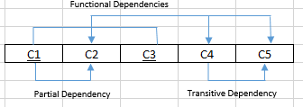A,

B, This table above is in 1nf and has both partial and transitive dependencies

C, After removing the partial dependencies the top table below is now in 3nf and the bottom table is in 2nf

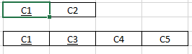

D, In order to make all the tables become 3nf we must remove transitive dependencies from table 2 above like so:

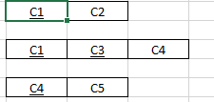

1. 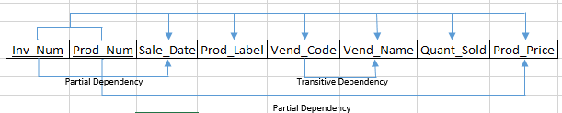A,

B, The table above has all of its partial and transitive dependencies and is in 1nf.

C, The tables below has had their partial dependencies removed and is now in 2nf. With the only one having any transitive dependencies left being the prod_num table.

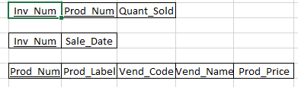

D, After removing the transitive dependency that was left in prod_num table this is the table in complete 3nf form and there is a new Vend_Code table:

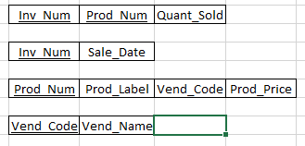

###### þÿCorresponding Relational Diagrams

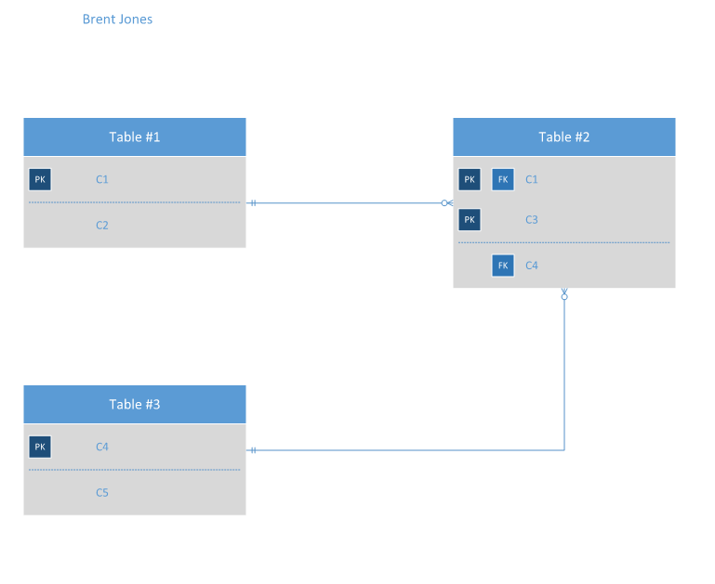

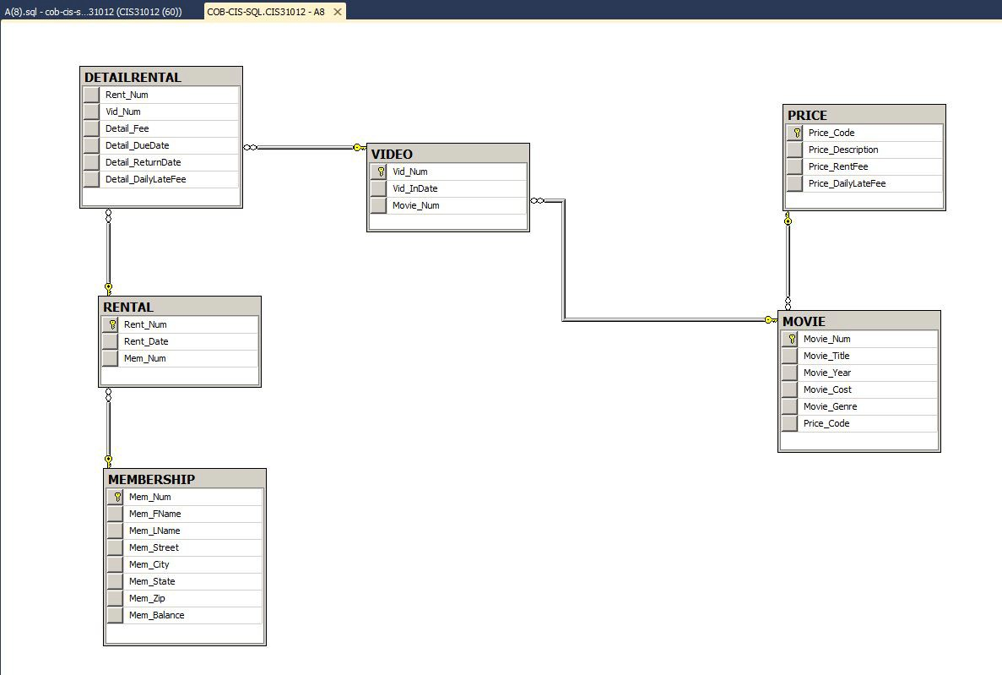

The following Class Diagrams correspond with the Messaging system and News and Related events wireframes made for the KSOA in the wireframes section.

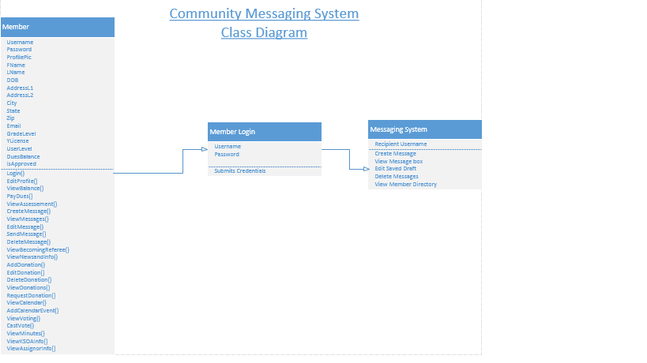

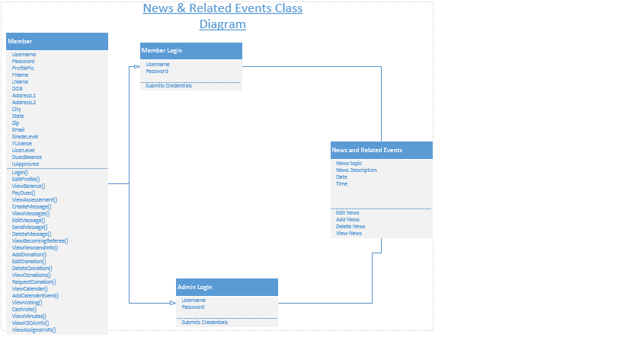

# Use Cases

This is a diagram of the current, or "As-Is," business processes within the KSOA. The blue circle at the top denotes the start of the process model, while the gray circle at the bottom represents the end. The blue diamonds represent decision nodes. If a person is a member of the KSOA they have different actions, represented by the green rounded rectangle shapes, that they can partake in. If a person is not a member of the KSOA, then the KSOA has limited actions as far as seeking out people to contact or have them become a member.

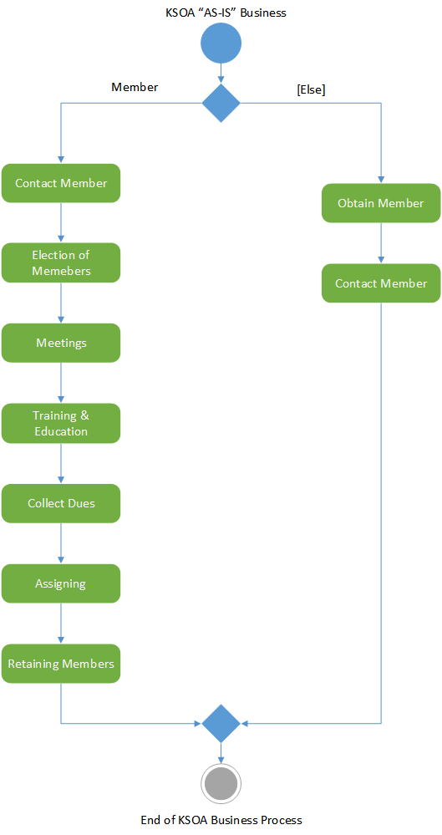

"To-Be" Process Model—KSOA System

This figure represents a high-level view of the overall KSOA System. The top blue circle represents the starting point for when a user visits the website, while the blue diamonds represent a choice the user makes, and the green rounded rectangles represent actions that support the business processes. The system is exited as shown by the gray circle once the user leaves the website.

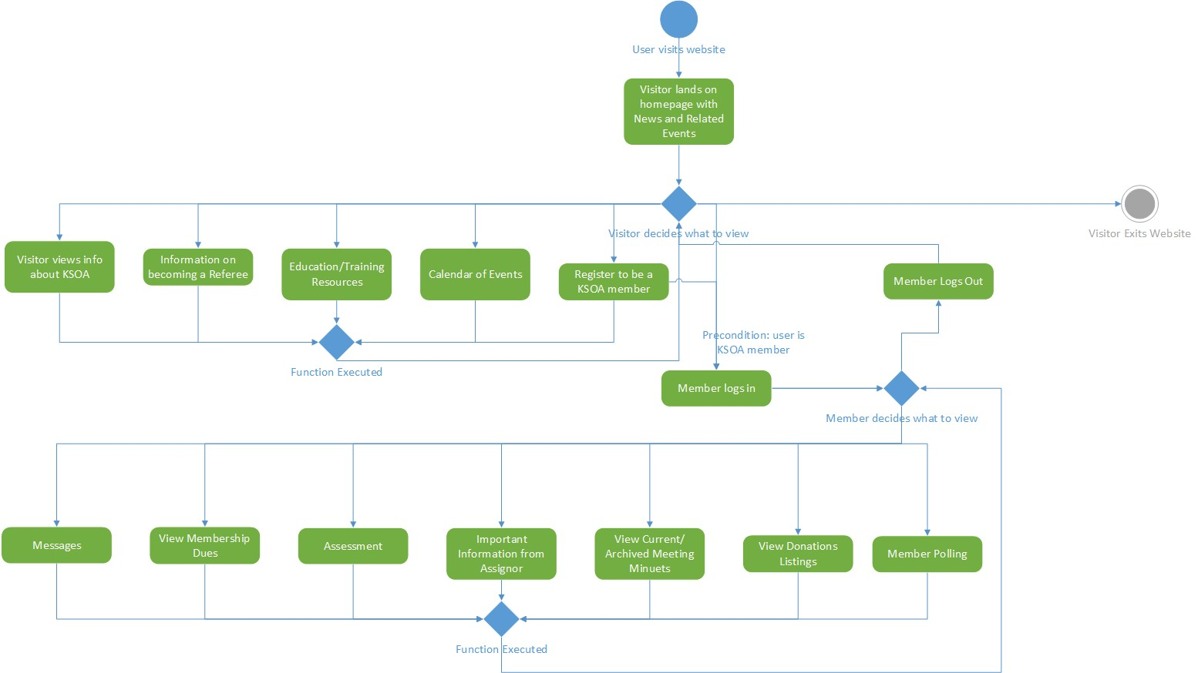

### Team ORS

**KSOA System Use Case Specification: Send_Message_to_Member**

##### Version 1.1

|  |  |
| --- | --- |
| KSOA System | Version: 1.1 |
| Use Case Specification: Contact_Member | Date: 11/15/15 |
| UC-36 | |

**Revision History**

|  |  |  |  |
| --- | --- | --- | --- |
| **Date** | **Version** | **Description** | **Author** |
| 11/15/15 | 1.1 | Update Use Case | Brent Jones |
| 11/10/15 | 1.0 | Create Use Case and Format | John Ballard |
|  |  |  |  |
|  |  |  |  |
|  |  |  |  |

|  |  |
| --- | --- |
| KSOA System | Version: 1.1 |
| Use Case Specification: Contact_Member | Date: 11/15/15 |
| UC-36 | |

### Table of Contents

1. Use-Case Name 4
   1. Brief Description 4
2. Flow of Events 4
   1. Basic Flow 4
      1. KSOA member logs in (UC-14) 4
      2. Member selects messaging section 4
      3. While member is in messaging section 4
         1. If member wishes to send a message to another member (or group of members) 4
            1. Member selects other member(s) by entering their usernames 4

Member types up message 4

Member selects to send message 4

Member saves message as draft 4

2.1.3.2 If member does not know username of desired recipients 4

2.1.3.2.1 Member clicks on forums tab and scrolls though until member is found 4

2.1.3.2.1.1 Member types usernames in the send message template and sends message 4

2.2 Alternative Flows 4

2.2.1 No alternative flow applicable at this time 4

1. Special Requirements 4
   1. No Special Requirements applicable at this time 4
2. Pre-conditions 4
   1. User must be a current KSOA member 4
   2. Login (UC-14) 4
3. Post-conditions 4
   1. Messages have been sent 4
   2. Member is transferred to self-contained KSOA Forums Plug-In 4
   3. Message has been saved as a draft 4

|  |  |
| --- | --- |
| KSOA System | Version: 1.1 |
| Use Case Specification: Contact_Member | Date: 11/15/15 |
| UC-36 | |

### Use Case Specification: Send Message to Member

1. Send Message to Member
   1. **Brief Description**

Allows members to message other members

1. Flow of Events
   1. **Basic Flow**
      1. *KSOA member logs in (UC-14)*
      2. *Member selects Messaging section*
      3. *While member is in messaging section*
         1. If member wishes to send a message to another member (or group of members)
            1. Member selects other member(s) by entering their usernames 2.1.3.1.1.1 Member types up message

2.1.3.1.1.2 Member selects to send message 2.1.3.1.1.3 Member saves message as draft

* + - 1. If member does not know username of desired recipients
         1. Member clicks on forums tab and scrolls though until member is found

2.1.3.2.1.1 Member types usernames in the send message template and sends message

* 1. **Alternative Flows**
     1. No alternative flows at this time

1. Special Requirements
   1. **No special requirements applicable at this time**
2. Pre-conditions
   1. **Actor is a KSOA Member**
   2. **Login (UC-14)**
3. Post-conditions
   1. **Messages have been sent**
   2. **Member is transferred to self-contained KSOA Forums Plug-In**
   3. **Message has been saved as a draft**

### Team ORS

**KSOA System Use Case Specification: Edit Message Drafts**

##### Version 1.0

|  |  |
| --- | --- |
| KSOA System | Version: 1.0 |
| Use Case Specification: Edit Message Drafts | Date: 11/15/15 |
| UC-37 | |

**Revision History**

|  |  |  |  |
| --- | --- | --- | --- |
| **Date** | **Version** | **Description** | **Author** |
| 11/15/15 | 1.0 | Update Use Case | Brent Jones |
|  |  |  |  |
|  |  |  |  |
|  |  |  |  |
|  |  |  |  |

|  |  |
| --- | --- |
| KSOA System | Version: 1.0 |
| Use Case Specification: Edit Message Drafts | Date: 11/15/15 |
| UC-37 | |

### Table of Contents

1. Use-Case Name 4
   1. Brief Description 4
2. Flow of Events 4
   1. Basic Flow 4
      1. KSOA member logs in (UC-14) 4
      2. Member selects messaging section 4
      3. While member is in messaging section 4
         1. If member wishes to Edit a message draft 4
            1. Member selects the Edit tab 4

2.1.3.1.1.1 Member makes desired changes to draft 4

* + - 1. If member wishes to send an edited draft 4
         1. Member uses edit tab to edit draft 4

2.1.3.2.1.1 Member types usernames in the “to” field and sends draft 4

2.2 Alternative Flows 4

2.2.1 No alternative flow applicable at this time 4

1. Special Requirements 4
   1. No Special Requirements applicable at this time 4
2. Pre-conditions 4
   1. User must be a current KSOA member 4
   2. Login (UC-14) 4
   3. Send Message (UC-36) 4
3. Post-conditions 4
   1. Drafts have now been sent as messages 4
   2. Already saved draft has been edited 4

|  |  |
| --- | --- |
| KSOA System | Version: 1.0 |
| Use Case Specification: Edit Message Drafts | Date: 11/15/15 |
| UC-37 | |

### Use Case Specification: Edit Message Drafts

1. Edit Message Drafts
   1. **Brief Description**

Allows Members to edit their already saved drafts or edit and send their drafts as messages

1. Flow of Events
   1. **Basic Flow**
      1. *KSOA member logs in (UC-14)*
      2. *Member selects Messaging section*
      3. *While member is in messaging section*
         1. If member wishes to Edit a message draft
            1. Member selects the Edit tab

Member makes desired changes to draft

* + - 1. If member wishes to send an edited draft
         1. Member uses edit tab to edit draft

Member types usernames in the “to” field and sends draft

* 1. **Alternative Flows**
     1. No alternative flows at this time

1. Special Requirements
   1. **No special requirements applicable at this time**
2. Pre-conditions
   1. **Actor is a KSOA Member**
   2. **Login (UC-14)**
   3. **Send Message to member (UC-36)**
3. Post-conditions
   1. **Drafts have now been sent as messages**
   2. **Already saved draft has been edited**

### Team ORS

**KSOA System Use Case Specification: View Messages**

##### Version 1.0

|  |  |
| --- | --- |
| KSOA System | Version: 1.0 |
| Use Case Specification: View Messages | Date: 11/15/15 |
| UC-38 | |

**Revision History**

|  |  |  |  |
| --- | --- | --- | --- |
| **Date** | **Version** | **Description** | **Author** |
| 11/15/15 | 1.0 | Update Use Case | Brent Jones |
|  |  |  |  |
|  |  |  |  |
|  |  |  |  |
|  |  |  |  |

|  |  |
| --- | --- |
| KSOA System | Version: 1.0 |
| Use Case Specification: View Messages | Date: 11/15/15 |
| UC-38 | |

### Table of Contents

1. Use-Case Name 4
   1. Brief Description 4
2. Flow of Events 4
   1. Basic Flow 4
      1. KSOA member logs in (UC-14) 4
      2. Member selects messaging section 4
      3. While member is in messaging section 4

2.1.3.1 Member wishes to view sent and received messages 4

2.1.3.1.1 Member selects the message box tab 4

2.1.3.1.1.1 Member clicks on the desired messages to view them 4

2.2 Alternative Flows 4

2.2.1 No alternative flow applicable at this time 4

1. Special Requirements 4
   1. No Special Requirements applicable at this time 4
2. Pre-conditions 4
   1. User must be a current KSOA member 4
   2. Login (UC-14) 4
3. Post-conditions 4
   1. Member has viewed desired messages 4

|  |  |
| --- | --- |
| KSOA System | Version: 1.0 |
| Use Case Specification: View Messages | Date: 11/15/15 |
| UC-38 | |

### Use Case Specification: View Messages

1. View Messages
   1. **Brief Description**

Allows Members to open and view their sent and received messages

1. Flow of Events
   1. **Basic Flow**
      1. *KSOA member logs in (UC-14)*
      2. *Member selects Messaging section*
      3. *While member is in messaging section*
         1. *Member wishes to view sent and received messages*
            1. *Member selects the message box tab*
            2. *Member clicks on the desired messages to view them*
   2. **Alternative Flows**
      1. No alternative flows at this time
2. Special Requirements
   1. **No special requirements applicable at this time**
3. Pre-conditions
   1. **Actor is a KSOA Member**
   2. **Login (UC-14)**
4. Post-conditions
   1. **Member has viewed desired messages**

### Team ORS

**KSOA System Use Case Specification: Delete Messages**

##### Version 1.0

|  |  |
| --- | --- |
| KSOA System | Version: 1.0 |
| Use Case Specification: Delete Messages | Date: 11/15/15 |
| UC-39 | |

**Revision History**

|  |  |  |  |
| --- | --- | --- | --- |
| **Date** | **Version** | **Description** | **Author** |
| 11/15/15 | 1.0 | Update Use Case | Brent Jones |
|  |  |  |  |
|  |  |  |  |
|  |  |  |  |
|  |  |  |  |

|  |  |
| --- | --- |
| KSOA System | Version: 1.0 |
| Use Case Specification: Delete Messages | Date: 11/15/15 |
| UC-39 | |

### Table of Contents

1. Use-Case Name 4
   1. Brief Description 4
2. Flow of Events 4
   1. Basic Flow 4
      1. KSOA member logs in (UC-14) 4
      2. Member selects messaging section 4
      3. While member is in messaging section 4
         1. Member wishes to Delete viewed or old messages 4
            1. Member selects the Delete tab 4

Member checks the desired messages to mark them 4

Member selects delete button to delete all the checked ones 4

2.2 Alternative Flows 4

2.2.1 No alternative flow applicable at this time 4

1. Special Requirements 4
   1. No Special Requirements applicable at this time 4
2. Pre-conditions 4
   1. User must be a current KSOA member 4
   2. Login (UC-14) 4
3. Post-conditions 4
   1. Member has deleted old or viewed messages 4

|  |  |
| --- | --- |
| KSOA System | Version: 1.0 |
| Use Case Specification: Delete Messages | Date: 11/15/15 |
| UC-39 | |

### Use Case Specification: Delete Messages

1. Delete Messages
   1. **Brief Description**

Allows Members to open and check for deletion their old or viewed messages

1. Flow of Events
   1. **Basic Flow**
      1. *KSOA member logs in (UC-14)*
      2. *Member selects Messaging section*
      3. *While member is in messaging section*

*2.1.3.1 Member wishes to delete viewed or old messages*

*2.1.3.1.1 Member selects the Delete tab*

*2.1.3.1.1.1 Member checks the desired messages to mark them* *2.1.3.1.1.2 Member selects delete button to delete all the checked ones*

* 1. **Alternative Flows**
     1. No alternative flows at this time

1. Special Requirements
   1. **No special requirements applicable at this time**
2. Pre-conditions
   1. **Actor is a KSOA Member**
   2. **Login (UC-14)**
3. Post-conditions
   1. **Member has deleted desired messages**